# Supplementary Information

## Pilot study

| Descriptive statistics and sex differences for participants ages 18-60 using population weights | | | | | | |
| --- | --- | --- | --- | --- | --- | --- |
| **Variable** | **Male** | | **Female** | | **Sexual Dimorphism** | |
| **N** | **Mean (SD)***1* | **N** | **Mean (SD)***1* | **Ratio** | **SMD***2* |
| **Age at first sex (years)** | 1,566 | 17.29 (3.90) | 1,575 | 17.45 (3.46) | 0.99 | -0.05 |
| **Lifetime number of sexual partners** | 1,684 | 12.03 (15.10) | 1,654 | 7.31 (8.88) | 1.65 | 0.38 |
| **Past year number of sexual partners** | 1,631 | 1.41 (2.30) | 1,606 | 1.02 (1.00) | 1.38 | 0.22 |
| **Combined Grip Strength (kg)** | 1,596 | 93.29 (17.00) | 1,526 | 59.28 (10.35) | 1.57 | 2.42 |
| **Age (Years)** | 1,684 | 38.39 (12.85) | 1,654 | 39.19 (12.54) | 0.98 | -0.06 |
| **Body mass index (kg/m^2)** | 1,675 | 28.34 (6.05) | 1,633 | 28.99 (7.62) | 0.98 | -0.09 |
| **Height (cm)** | 1,677 | 176.40 (7.58) | 1,636 | 163.05 (7.08) | 1.08 | 1.82 |
| **Weight (kg)** | 1,675 | 88.31 (20.25) | 1,633 | 77.04 (20.80) | 1.15 | 0.55 |
| **White blood cell count (1000 cells/µL)** | 1,628 | 6.92 (2.02) | 1,600 | 7.22 (2.11) | 0.96 | -0.14 |
| **Hemoglobin (g/dL)** | 1,628 | 15.13 (1.08) | 1,600 | 13.28 (1.16) | 1.14 | 1.65 |
| **Testosterone (ng/dL)** | 1,571 | 410.86 (171.16) | 1,536 | 26.02 (24.08) | 15.79 | 3.15 |
| **Chronic Disease Score (0-6)** | 1,529 | 0.40 (0.65) | 1,515 | 0.56 (0.82) | 0.71 | -0.22 |
| **Disease Impairment Score (0-5)** | 1,684 | 0.19 (0.67) | 1,654 | 0.28 (0.85) | 0.68 | -0.12 |
| **Depression Score (0-27)** | 1,678 | 2.67 (4.01) | 1,650 | 3.47 (4.52) | 0.77 | -0.19 |
| **Dietary energy intake (kcals)** | 1,435 | 2,545.36 (844.86) | 1,466 | 1,850.41 (614.10) |  | 0.94 |
| **Dietary protein intake (grams)** | 1,435 | 99.54 (36.89) | 1,466 | 69.82 (25.59) | 1.43 | 0.94 |
| **Food Insecurity Rating (1-4)** | 1,680 | 1.53 (0.96) | 1,650 | 1.58 (0.99) | 0.97 | -0.05 |
| **Total MET** | 1,676 | 89.20 (115.46) | 1,651 | 42.38 (67.20) | 2.10 | 0.50 |
| **Partnered** | 1,537 | 880 (59%) | 1,521 | 828 (61%) |  |  |
| **Education** |  |  |  |  |  |  |
| 1 | 1,684 | 90 (3.9%) | 1,654 | 70 (3.0%) |  |  |
| 2 | 1,684 | 269 (12%) | 1,654 | 225 (9.9%) |  |  |
| 3 | 1,684 | 388 (23%) | 1,654 | 303 (17%) |  |  |
| 4 | 1,684 | 521 (32%) | 1,654 | 581 (36%) |  |  |
| 5 | 1,684 | 416 (29%) | 1,654 | 475 (35%) |  |  |
| **Race and Ethnicity** |  |  |  |  |  |  |
| MexicanAmerican | 1,684 | 204 (9.9%) | 1,654 | 173 (8.2%) |  |  |
| OtherHispanic | 1,684 | 154 (6.7%) | 1,654 | 179 (7.2%) |  |  |
| NonHispanicWhite | 1,684 | 615 (65%) | 1,654 | 559 (64%) |  |  |
| NonHispanicBlack | 1,684 | 403 (10%) | 1,654 | 479 (14%) |  |  |
| NonHispanicAsian | 1,684 | 240 (4.8%) | 1,654 | 212 (4.6%) |  |  |
| OtherRace | 1,684 | 68 (2.8%) | 1,654 | 52 (2.7%) |  |  |
| **Perceived abnormal weight** | 1,677 | 807 (51%) | 1,650 | 1,062 (65%) |  |  |
| **Special equipment needed to walk** | 1,537 | 62 (2.6%) | 1,521 | 90 (4.5%) |  |  |
| **Work involves vigorous activity** | 1,684 | 459 (31%) | 1,654 | 174 (12%) |  |  |
| **Work involves moderate activity** | 1,684 | 676 (44%) | 1,654 | 494 (34%) |  |  |
| **Recreation involves vigorous activity** | 1,684 | 639 (37%) | 1,654 | 386 (25%) |  |  |
| **Recreation involves moderate activity** | 1,684 | 758 (49%) | 1,654 | 756 (51%) |  |  |
| *1* Weighted means and standard deviations shown for continuous variables, unweighted n (%) for categorical variables | | | | | | |
| *2* Standardized Mean Difference | | | | | | |

Table S1: Descriptive statistics of pilot study sample.

### Models of mating success with anthropometric, socioeconomic, health, hormone, and physical activity controls

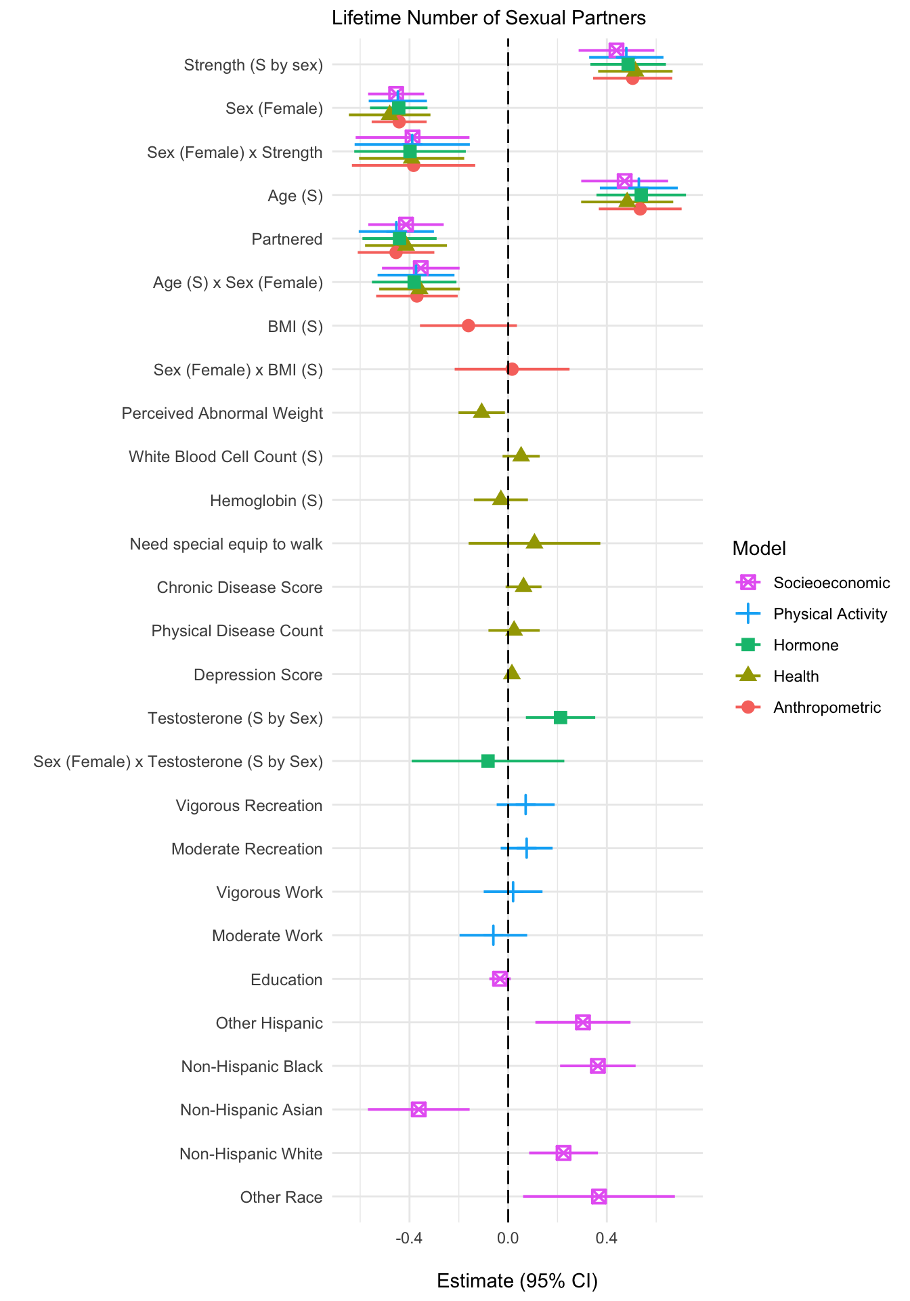

Figure S1: Models of lifetime number of sex partners.

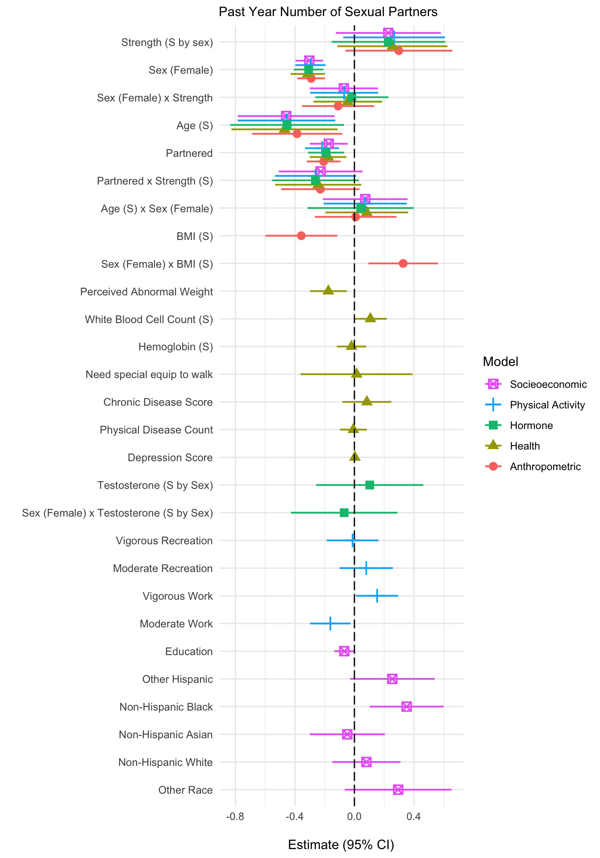

Figure S2: Models past year sex partners.

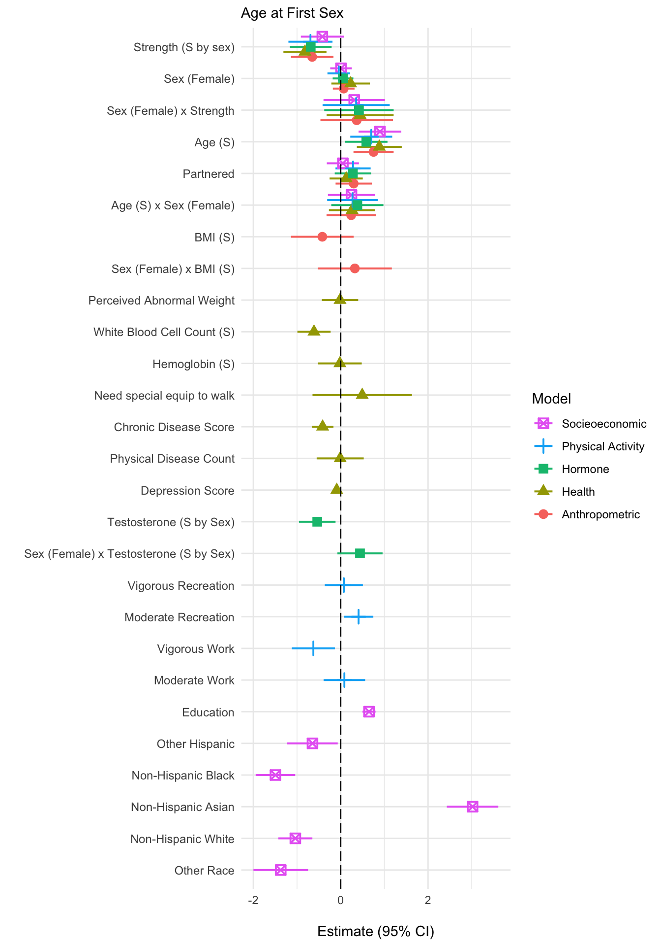

Figure S3: Models of age at first sex

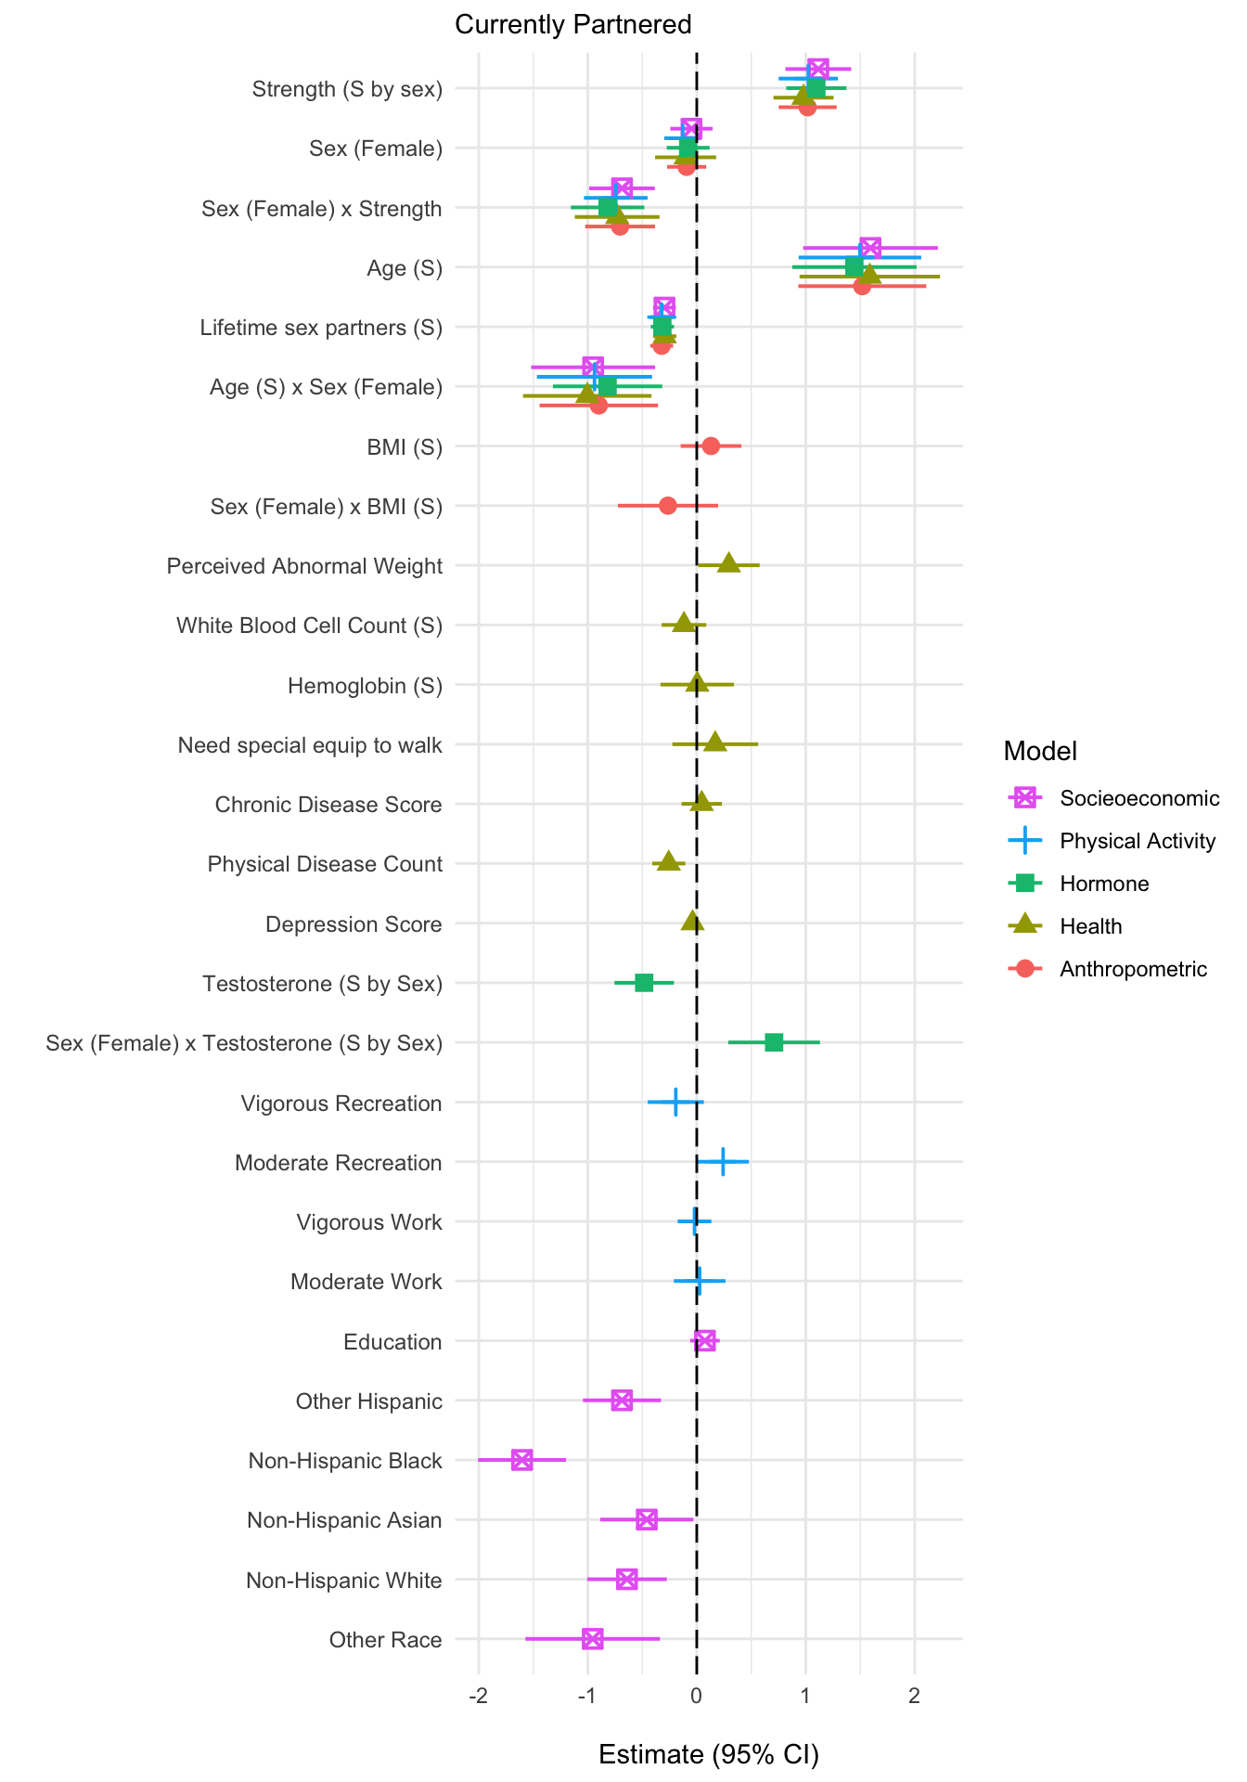

Figure S4: Models of partnered status

### The negative association of numbers of lifetime sexual partners on partnered status

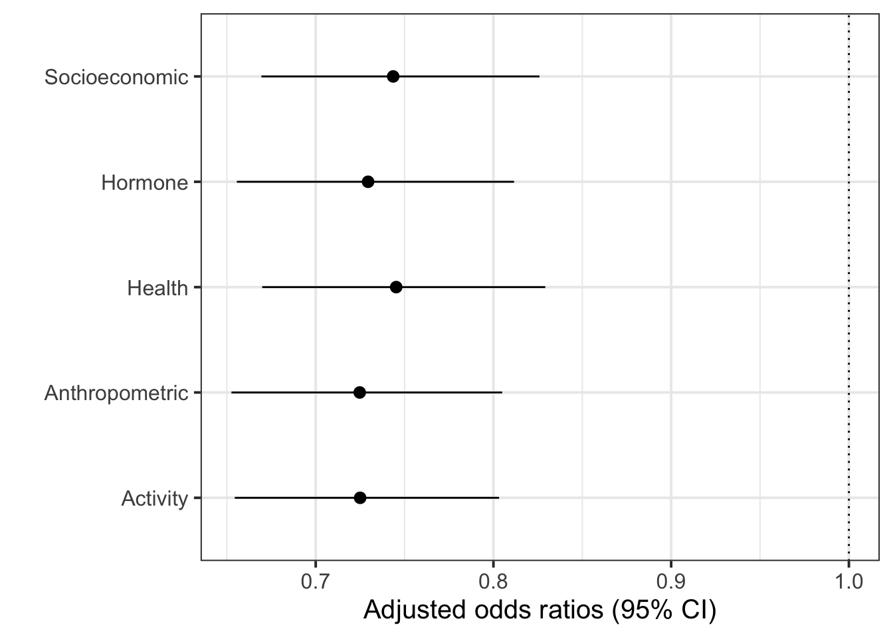

Figure S5: The adjusted odds ratios of numbers of lifetime partners on partnered status. In these models, lifetime partners was divided by 10, the interquartile range.

### Correlation matrices of study variables

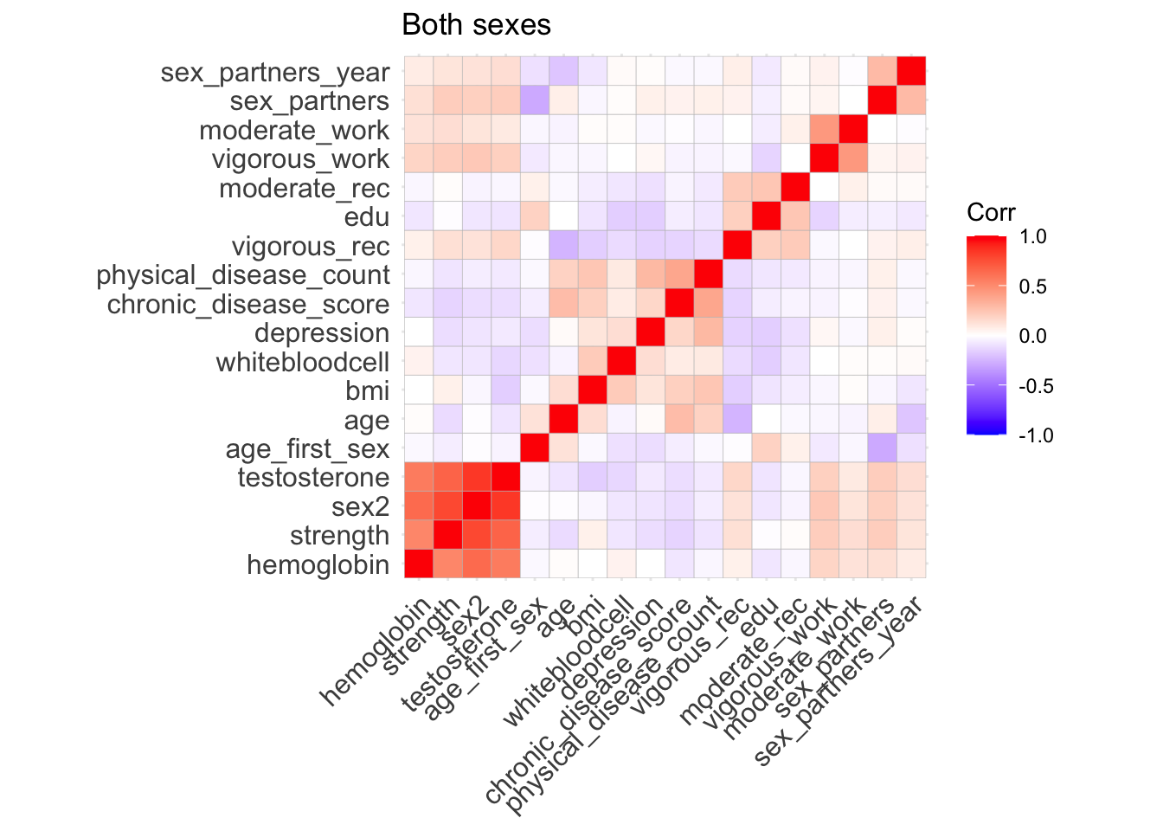

Figure S6: Correlation matrix of study variables (both sexes). Rows and columns ordered by hierarchical clustering.

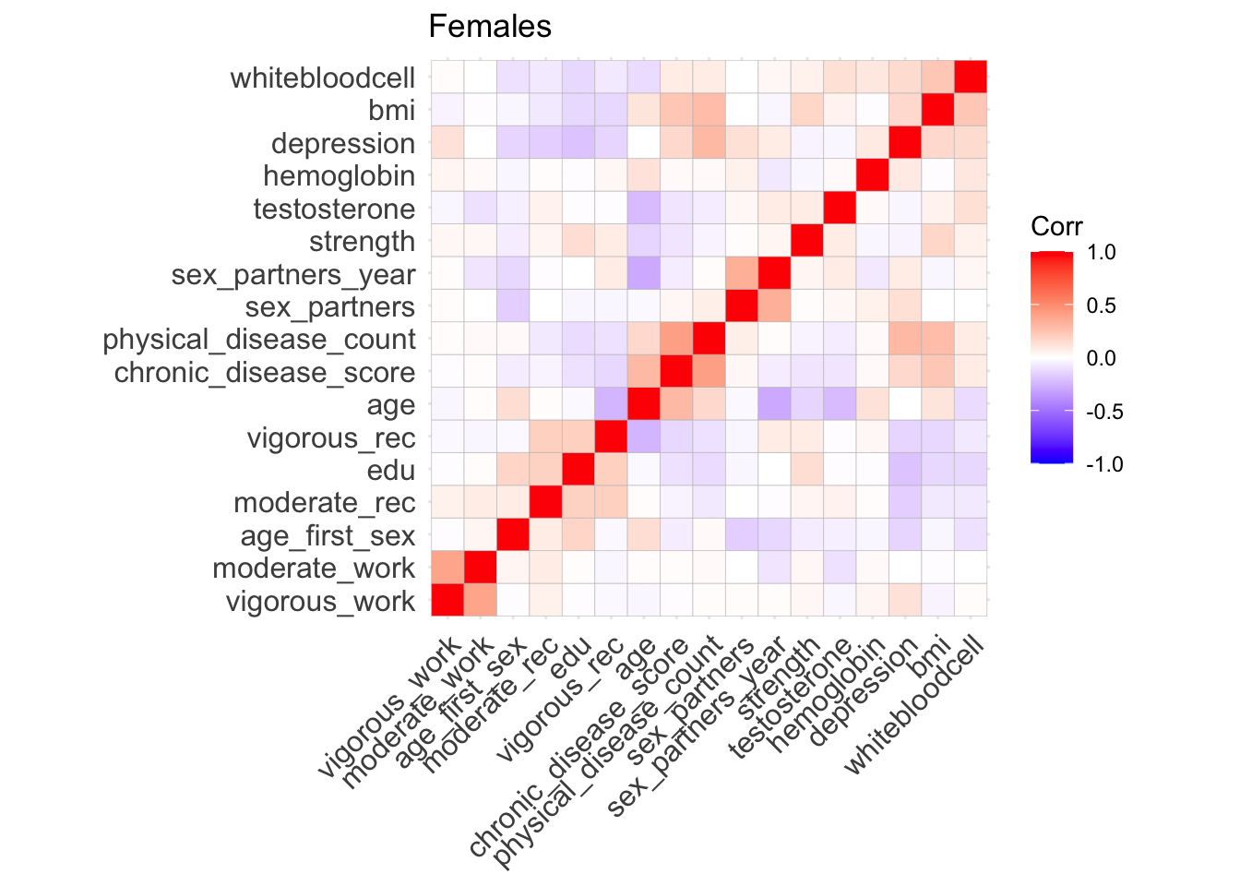

Figure S7: Correlation matrix of study variables for females only. Rows and columns ordered by hierarchical clustering.

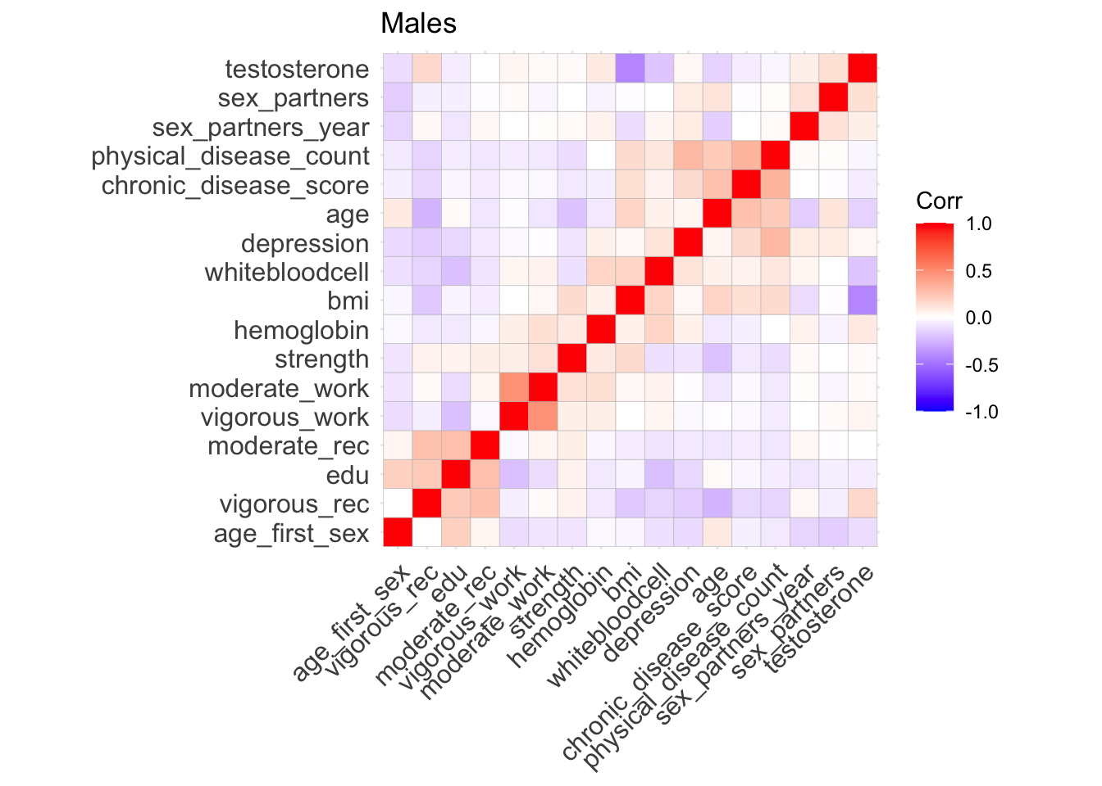

Figure S8: Correlation matrix of study variables for males only. Rows and columns ordered by hierarchical clustering.

### Regression tables

**Lifetime number of partners**

|  | **Anthropometric** | **Socioeconomic** | **Health** | **Activity** | **Hormone** |
| --- | --- | --- | --- | --- | --- |
| (Intercept) | 2.712 | 2.611 | 2.685 | 2.674 | 2.706 |
|  | (0.072) | (0.095) | (0.100) | (0.075) | (0.070) |
| age_centered | 0.535 | 0.472 | 0.482 | 0.530 | 0.539 |
|  | (0.086) | (0.090) | (0.095) | (0.081) | (0.093) |
| sexfemale | −0.442 | −0.454 | −0.480 | −0.447 | −0.444 |
|  | (0.057) | (0.058) | (0.084) | (0.060) | (0.059) |
| strength_centered | 0.505 | 0.439 | 0.515 | 0.479 | 0.486 |
|  | (0.082) | (0.078) | (0.077) | (0.077) | (0.078) |
| partneredTRUE | −0.455 | −0.414 | −0.414 | −0.453 | −0.440 |
|  | (0.079) | (0.078) | (0.085) | (0.078) | (0.077) |
| bmi_centered | −0.161 |  |  |  |  |
|  | (0.100) |  |  |  |  |
| age_centered × sexfemale | −0.370 | −0.354 | −0.359 | −0.374 | −0.381 |
|  | (0.084) | (0.080) | (0.083) | (0.080) | (0.087) |
| sexfemale × strength_centered | −0.383 | −0.388 | −0.391 | −0.389 | −0.398 |
|  | (0.128) | (0.118) | (0.109) | (0.119) | (0.115) |
| sexfemale × bmi_centered | 0.016 |  |  |  |  |
|  | (0.119) |  |  |  |  |
| edu |  | −0.033 |  |  |  |
|  |  | (0.022) |  |  |  |
| raceOtherHispanic |  | 0.303 |  |  |  |
|  |  | (0.098) |  |  |  |
| raceNonHispanicWhite |  | 0.224 |  |  |  |
|  |  | (0.071) |  |  |  |
| raceNonHispanicBlack |  | 0.364 |  |  |  |
|  |  | (0.078) |  |  |  |
| raceNonHispanicAsian |  | −0.363 |  |  |  |
|  |  | (0.105) |  |  |  |
| raceOtherRace |  | 0.368 |  |  |  |
|  |  | (0.157) |  |  |  |
| perceived_abnormal_weightTRUE |  |  | −0.107 |  |  |
|  |  |  | (0.048) |  |  |
| whitebloodcell_centered |  |  | 0.053 |  |  |
|  |  |  | (0.038) |  |  |
| hemoglobin_centered |  |  | −0.030 |  |  |
|  |  |  | (0.056) |  |  |
| special_equipmentTRUE |  |  | 0.107 |  |  |
|  |  |  | (0.136) |  |  |
| chronic_disease_score |  |  | 0.062 |  |  |
|  |  |  | (0.037) |  |  |
| physical_disease_count |  |  | 0.024 |  |  |
|  |  |  | (0.053) |  |  |
| depression |  |  | 0.015 |  |  |
|  |  |  | (0.007) |  |  |
| vigorous_rec |  |  |  | 0.071 |  |
|  |  |  |  | (0.060) |  |
| moderate_rec |  |  |  | 0.075 |  |
|  |  |  |  | (0.054) |  |
| vigorous_work |  |  |  | 0.020 |  |
|  |  |  |  | (0.061) |  |
| moderate_work |  |  |  | −0.060 |  |
|  |  |  |  | (0.070) |  |
| testosterone_sex_centered |  |  |  |  | 0.212 |
|  |  |  |  |  | (0.072) |
| sexfemale × testosterone_sex_centered |  |  |  |  | −0.082 |
|  |  |  |  |  | (0.158) |
| Num.Obs. | 2837 | 2853 | 2742 | 2853 | 2673 |

Table S2: Quasi-Poisson Regression Models of Lifetime Number of Sexual Partners

**Past year number of partners**

|  | **Anthropometric** | **Socioeconomic** | **Health** | **Activity** | **Hormone** |
| --- | --- | --- | --- | --- | --- |
| (Intercept) | 0.399 | 0.524 | 0.445 | 0.403 | 0.399 |
|  | (0.065) | (0.144) | (0.084) | (0.085) | (0.071) |
| age_centered | −0.385 | −0.458 | −0.469 | −0.456 | −0.453 |
|  | (0.155) | (0.166) | (0.182) | (0.167) | (0.195) |
| sexfemale | −0.291 | −0.303 | −0.313 | −0.296 | −0.307 |
|  | (0.047) | (0.047) | (0.059) | (0.052) | (0.051) |
| strength_centered | 0.298 | 0.228 | 0.255 | 0.267 | 0.228 |
|  | (0.183) | (0.180) | (0.189) | (0.174) | (0.195) |
| partneredTRUE | −0.207 | −0.172 | −0.177 | −0.217 | −0.190 |
|  | (0.058) | (0.065) | (0.063) | (0.058) | (0.062) |
| bmi_centered | −0.357 |  |  |  |  |
|  | (0.124) |  |  |  |  |
| age_centered × sexfemale | 0.009 | 0.073 | 0.083 | 0.072 | 0.042 |
|  | (0.140) | (0.145) | (0.142) | (0.143) | (0.182) |
| sexfemale × strength_centered | −0.110 | −0.071 | −0.044 | −0.069 | −0.017 |
|  | (0.124) | (0.117) | (0.118) | (0.117) | (0.125) |
| strength_centered × partneredTRUE | −0.229 | −0.227 | −0.243 | −0.261 | −0.262 |
|  | (0.134) | (0.144) | (0.148) | (0.139) | (0.149) |
| sexfemale × bmi_centered | 0.327 |  |  |  |  |
|  | (0.119) |  |  |  |  |
| edu |  | −0.068 |  |  |  |
|  |  | (0.034) |  |  |  |
| raceOtherHispanic |  | 0.255 |  |  |  |
|  |  | (0.145) |  |  |  |
| raceNonHispanicWhite |  | 0.081 |  |  |  |
|  |  | (0.117) |  |  |  |
| raceNonHispanicBlack |  | 0.351 |  |  |  |
|  |  | (0.127) |  |  |  |
| raceNonHispanicAsian |  | −0.048 |  |  |  |
|  |  | (0.129) |  |  |  |
| raceOtherRace |  | 0.294 |  |  |  |
|  |  | (0.183) |  |  |  |
| perceived_abnormal_weightTRUE |  |  | −0.175 |  |  |
|  |  |  | (0.063) |  |  |
| whitebloodcell_centered |  |  | 0.107 |  |  |
|  |  |  | (0.056) |  |  |
| hemoglobin_centered |  |  | −0.020 |  |  |
|  |  |  | (0.050) |  |  |
| special_equipmentTRUE |  |  | 0.015 |  |  |
|  |  |  | (0.192) |  |  |
| chronic_disease_score |  |  | 0.084 |  |  |
|  |  |  | (0.084) |  |  |
| physical_disease_count |  |  | −0.007 |  |  |
|  |  |  | (0.046) |  |  |
| depression |  |  | 0.003 |  |  |
|  |  |  | (0.009) |  |  |
| vigorous_rec |  |  |  | −0.012 |  |
|  |  |  |  | (0.089) |  |
| moderate_rec |  |  |  | 0.079 |  |
|  |  |  |  | (0.091) |  |
| vigorous_work |  |  |  | 0.153 |  |
|  |  |  |  | (0.073) |  |
| moderate_work |  |  |  | −0.162 |  |
|  |  |  |  | (0.069) |  |
| testosterone_sex_centered |  |  |  |  | 0.103 |
|  |  |  |  |  | (0.184) |
| sexfemale × testosterone_sex_centered |  |  |  |  | −0.069 |
|  |  |  |  |  | (0.183) |
| Num.Obs. | 2748 | 2763 | 2656 | 2763 | 2591 |

Table S3: Quasi-Poisson Regression Models of Past Year Number of Sexual Partners

**Age at first sex**

|  | **Anthropometric** | **Socioeconomic** | **Health** | **Activity** | **Hormone** |
| --- | --- | --- | --- | --- | --- |
| (Intercept) | 17.202 | 15.676 | 17.718 | 17.143 | 17.217 |
|  | (0.179) | (0.282) | (0.189) | (0.212) | (0.179) |
| age_centered | 0.753 | 0.899 | 0.884 | 0.700 | 0.587 |
|  | (0.235) | (0.250) | (0.262) | (0.245) | (0.248) |
| sexfemale | 0.069 | 0.008 | 0.228 | −0.044 | 0.054 |
|  | (0.127) | (0.126) | (0.225) | (0.132) | (0.121) |
| strength_centered | −0.652 | −0.420 | −0.818 | −0.692 | −0.686 |
|  | (0.248) | (0.251) | (0.252) | (0.257) | (0.244) |
| partneredTRUE | 0.298 | 0.050 | 0.126 | 0.284 | 0.280 |
|  | (0.212) | (0.188) | (0.194) | (0.205) | (0.212) |
| bmi_centered | −0.420 |  |  |  |  |
|  | (0.366) |  |  |  |  |
| age_centered × sexfemale | 0.240 | 0.247 | 0.260 | 0.270 | 0.382 |
|  | (0.288) | (0.275) | (0.270) | (0.296) | (0.304) |
| sexfemale × strength_centered | 0.367 | 0.310 | 0.445 | 0.354 | 0.419 |
|  | (0.424) | (0.359) | (0.392) | (0.392) | (0.405) |
| sexfemale × bmi_centered | 0.324 |  |  |  |  |
|  | (0.432) |  |  |  |  |
| raceOtherHispanic |  | −0.646 |  |  |  |
|  |  | (0.295) |  |  |  |
| raceNonHispanicWhite |  | −1.038 |  |  |  |
|  |  | (0.199) |  |  |  |
| raceNonHispanicBlack |  | −1.494 |  |  |  |
|  |  | (0.231) |  |  |  |
| raceNonHispanicAsian |  | 3.020 |  |  |  |
|  |  | (0.301) |  |  |  |
| raceOtherRace |  | −1.373 |  |  |  |
|  |  | (0.319) |  |  |  |
| edu |  | 0.649 |  |  |  |
|  |  | (0.076) |  |  |  |
| perceived_abnormal_weightTRUE |  |  | −0.015 |  |  |
|  |  |  | (0.212) |  |  |
| whitebloodcell_centered |  |  | −0.611 |  |  |
|  |  |  | (0.194) |  |  |
| hemoglobin_centered |  |  | −0.018 |  |  |
|  |  |  | (0.255) |  |  |
| special_equipmentTRUE |  |  | 0.493 |  |  |
|  |  |  | (0.581) |  |  |
| chronic_disease_score |  |  | −0.414 |  |  |
|  |  |  | (0.127) |  |  |
| physical_disease_count |  |  | −0.011 |  |  |
|  |  |  | (0.275) |  |  |
| depression |  |  | −0.090 |  |  |
|  |  |  | (0.032) |  |  |
| vigorous_rec |  |  |  | 0.072 |  |
|  |  |  |  | (0.223) |  |
| moderate_rec |  |  |  | 0.410 |  |
|  |  |  |  | (0.173) |  |
| vigorous_work |  |  |  | −0.626 |  |
|  |  |  |  | (0.252) |  |
| moderate_work |  |  |  | 0.085 |  |
|  |  |  |  | (0.243) |  |
| testosterone_sex_centered |  |  |  |  | −0.536 |
|  |  |  |  |  | (0.214) |
| sexfemale × testosterone_sex_centered |  |  |  |  | 0.442 |
|  |  |  |  |  | (0.264) |
| Num.Obs. | 2702 | 2718 | 2619 | 2718 | 2557 |

Table S4: Gaussian Regression Models of Age at First Sex

**Partnered status**

|  | **Anthropometric** | **Socioeconomic** | **Health** | **Activity** | **Hormone** |
| --- | --- | --- | --- | --- | --- |
| (Intercept) | 0.774 | 1.139 | 0.743 | 0.726 | 0.774 |
|  | (0.118) | (0.240) | (0.200) | (0.120) | (0.123) |
| sex_partners_scaled | −0.322 | −0.296 | −0.294 | −0.322 | −0.315 |
|  | (0.054) | (0.054) | (0.054) | (0.052) | (0.054) |
| age_centered | 1.518 | 1.594 | 1.588 | 1.497 | 1.446 |
|  | (0.300) | (0.316) | (0.329) | (0.287) | (0.291) |
| sexfemale | −0.093 | −0.048 | −0.102 | −0.129 | −0.079 |
|  | (0.092) | (0.099) | (0.143) | (0.086) | (0.100) |
| strength_centered | 1.017 | 1.115 | 0.979 | 1.023 | 1.097 |
|  | (0.136) | (0.154) | (0.141) | (0.139) | (0.141) |
| bmi_centered | 0.131 |  |  |  |  |
|  | (0.142) |  |  |  |  |
| age_centered × sexfemale | −0.899 | −0.951 | −1.004 | −0.938 | −0.818 |
|  | (0.277) | (0.290) | (0.301) | (0.270) | (0.256) |
| sexfemale × strength_centered | −0.703 | −0.686 | −0.730 | −0.743 | −0.818 |
|  | (0.164) | (0.154) | (0.198) | (0.149) | (0.172) |
| sexfemale × bmi_centered | −0.264 |  |  |  |  |
|  | (0.235) |  |  |  |  |
| edu |  | 0.075 |  |  |  |
|  |  | (0.069) |  |  |  |
| raceOtherHispanic |  | −0.686 |  |  |  |
|  |  | (0.183) |  |  |  |
| raceNonHispanicWhite |  | −0.640 |  |  |  |
|  |  | (0.186) |  |  |  |
| raceNonHispanicBlack |  | −1.603 |  |  |  |
|  |  | (0.206) |  |  |  |
| raceNonHispanicAsian |  | −0.458 |  |  |  |
|  |  | (0.218) |  |  |  |
| raceOtherRace |  | −0.955 |  |  |  |
|  |  | (0.315) |  |  |  |
| perceived_abnormal_weightTRUE |  |  | 0.295 |  |  |
|  |  |  | (0.144) |  |  |
| whitebloodcell_centered |  |  | −0.117 |  |  |
|  |  |  | (0.104) |  |  |
| hemoglobin_centered |  |  | 0.004 |  |  |
|  |  |  | (0.172) |  |  |
| special_equipmentTRUE |  |  | 0.169 |  |  |
|  |  |  | (0.201) |  |  |
| chronic_disease_score |  |  | 0.046 |  |  |
|  |  |  | (0.094) |  |  |
| physical_disease_count |  |  | −0.257 |  |  |
|  |  |  | (0.077) |  |  |
| depression |  |  | −0.038 |  |  |
|  |  |  | (0.012) |  |  |
| vigorous_rec |  |  |  | −0.192 |  |
|  |  |  |  | (0.131) |  |
| moderate_rec |  |  |  | 0.242 |  |
|  |  |  |  | (0.120) |  |
| vigorous_work |  |  |  | −0.021 |  |
|  |  |  |  | (0.079) |  |
| moderate_work |  |  |  | 0.027 |  |
|  |  |  |  | (0.121) |  |
| testosterone_sex_centered |  |  |  |  | −0.483 |
|  |  |  |  |  | (0.139) |
| sexfemale × testosterone_sex_centered |  |  |  |  | 0.710 |
|  |  |  |  |  | (0.215) |
| Num.Obs. | 2837 | 2853 | 2742 | 2853 | 2673 |

Table S5: Logistic Regression Models of Partnered Status